
Dashboard Design

Date | 27 October 2026
Team ID | Individual Project
Project Name | EV Market Performance & Insights Dashboard
Maximum Marks | 5 Marks

Creating an effective dashboard involves thoughtful design to ensure that the presented information is clear, relevant, and easily understandable for the intended audience. Here are some key principles and best practices for dashboard design
Activity 1: Interactive and visually appealing dashboards
Creating interactive and visually appealing dashboards involves a combination of thoughtful design, effective use of visual elements, and the incorporation of interactive features. Here are some tips to help you design dashboards that are both visually appealing and engaging for users so take care of below points
- Clear and Intuitive Layout
- Use Appropriate Visualizations
- Colour and Theming
- Interactive Filters and Slicers
- Drill-Down Capabilities
- Responsive Design
- Custom Visuals and Icons
- Use of Infographics

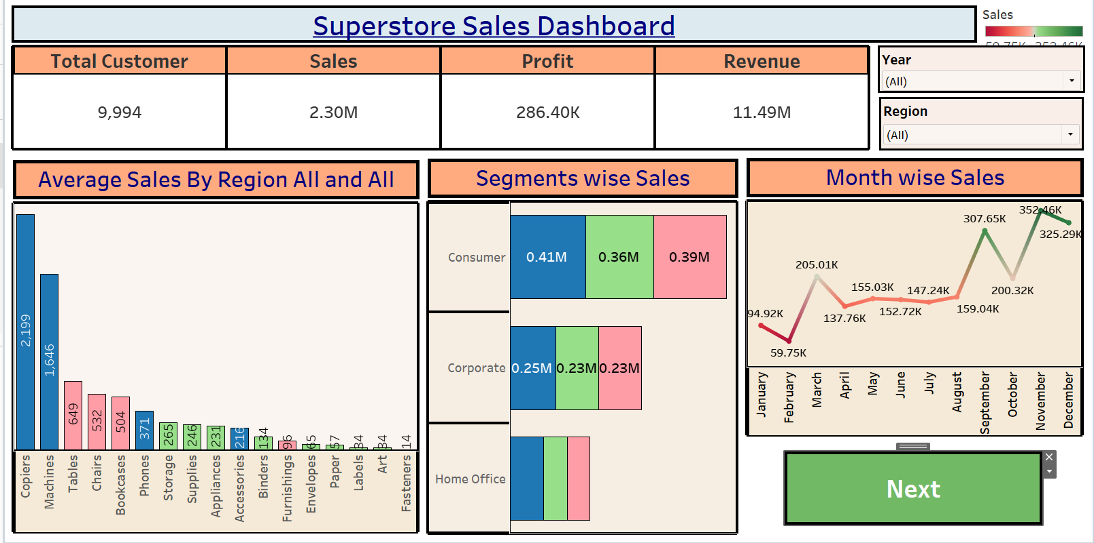
Note: Highlight the major outcomes in form of bullet points

Here are five potential outcomes from the dashboard image provided:

Activity 2
Publish Dashboard on Tableau Public and Paste the Dashboard Public link below:

https://public.tableau.com/views/SalesDashboard_17247660582000/Dashboard1?:language=en-US&publish=yes&:sid=&:redirect=auth&:display_count=n&:origin=viz_share_link
Major Outcomes
• The dashboard summarizes approximately 199,999 distinct Vehicle Ids.\n• Average battery capacity is approximately 78.24 kWh.\n• Average driving range is approximately 324.5 km.\n• A manufacturer chart supports comparison of EV record counts across available manufacturers.\n• A manufacturing-country chart shows the distribution of EV records by country.
Dashboard Public Link
https://public.tableau.com/views/EVMarketAnalysisDashboard_17930190186570/Dashboard1
Project-specific design: KPI cards for distinct Vehicle Id count, average battery capacity (kWh) and average driving range (km), followed by manufacturer and country count charts. Use concise labels, consistent number formatting, readable category names and a clear title. No unverified filter or drill-down feature is claimed.
Dashboard Public Link: https://public.tableau.com/views/EVMarketAnalysisDashboard_17930190186570/Dashboard1

